BI Deployment, Monitoring, Backup & Recovery Strategy
Experiment 10: Enterprise Maintenance, Governance & Business Continuity
Lab Experiment: Experiment 10 — BI Deployment & Maintenance | Dataset: Global Superstore Dataset (51,290 Records)
Enterprise Platform: Microsoft Power BI Desktop / Service, Azure DevOps | Deliverable Focus: Deployment Plan, Monitoring Matrix, Disaster Recovery

1. Aim & Objectives
To understand and design comprehensive Business Intelligence deployment, operational telemetry monitoring, backup schedules, and disaster recovery procedures using Microsoft Power BI Desktop and Service. This strategy ensures high availability, operational reliability, and uninterrupted business continuity for critical organizational dashboards and analytical assets.
- Identify all BI assets (datasets, dashboards, reports, and workspaces) and formulate a staged deployment plan.
- Establish a structured Power BI workspace architecture, role governance (Admin, Member, Contributor, Viewer), and access controls.
- Design an operational telemetry monitoring matrix tracking dataset refresh status, dashboard adoption, and query performance.
- Define version-controlled backup schedules and standardized asset restoration workflows.
- Simulate an executive disaster recovery scenario (accidental dashboard deletion prior to an executive meeting) and establish emergency recovery protocols.
2. Supporting BI Dashboard Architecture
The operational lifecycle strategy governs the executive solution engineered across Experiments 6 through 9. The production asset library manages 51,290 global orders accounting for $12,642,501.91 in Total Sales, $1,467,457.29 in Total Profit, and 25,728 distinct transactions. Figure 10.1 displays the core executive interface, scorecard quotas, and regional breakdown which must be guarded against system outages and unauthorized alterations.
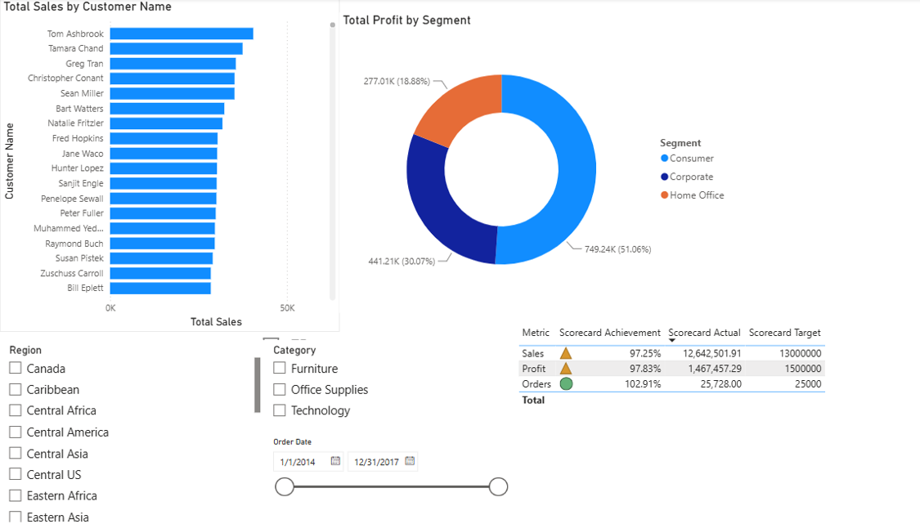
Figure 10.1: Global Superstore Executive Performance Dashboard Governed by BI Lifecycle Strategy
3. BI Deployment Planning & Asset Inventory (Part A)
BI deployment transitions tested development artifacts into a governed, scalable production environment. A staged release pipeline ensures data integrity, verifies formula logic, and validates security permissions before exposing reports to end users. Table 10.1 inventories all core assets and defines their deployment sequencing.
Asset Name | Asset Type | Deployment Target | Lead Owner | Validation & Acceptance Method
Global Superstore Orders Dataset | Semantic Model / Dataset | Power BI Service (Production Workspace) | BI Data Engineer | Row-count reconciliation (51,290 rows) and scheduled gateway refresh test.
Executive Performance Dashboard | Power BI Dashboard Tile Collection | Executive App Workspace | BI Lead Architect | Verify 4 core KPI card values ($12.64M sales, $1.47M profit) and mobile rendering.
Regional Sales Diagnostic Report | Interactive PBIX Report | Commercial App Workspace | Senior BI Developer | Test interactive regional slicers, Top 10 customer filters, and RLS rules.
Target Scorecard Matrix | Scorecard / Metrics Visual | Executive Dashboard | BI Operations Analyst | Validate target thresholds ($13M sales, $1.5M profit) and status color formatting.
Global Superstore RLS Security Model | Security Role Configuration | Power BI Dataset Security | Security Admin | Execute 'View as Role' audits; verify Western Europe sees strictly $1.73M sales.

4. Workspace Architecture & Role Governance (Part B)
A resilient BI deployment requires segregating development, testing, and production content. Power BI Workspaces provide organizational boundaries, while Power BI Apps distribute approved, read-only content to business consumers. Table 10.2 details the workspace role assignment structure.
Workspace Role | Assigned Personnel | Granted Capabilities | Restrictions & Security Controls
Admin | BI Delivery Director, Lead BI Architect | Full control: update workspace settings, assign/remove members, delete workspace, configure gateways. | Restricted to 2 named senior technical leads to eliminate single points of failure.
Member | Senior BI Developers, Data Engineers | Publish content, edit reports/dashboards, configure scheduled refreshes, share apps with users. | Cannot delete production workspace or modify Admin permissions.
Contributor | Business Analysts, Financial Modelers | Create, edit, and modify reports and dataset definitions inside the workspace. | Cannot publish workspace apps, modify workspace access, or share items externally.
Viewer | CEO, Department Heads, Regional Managers, Field Staff | View and interact with published reports/dashboards; read data via Power BI Apps. | Strictly read-only; cannot edit visuals, export underlying data models, or alter filters.

Enterprise Workspace Governance Guidelines
- Naming Standards: Workspaces follow standardized syntax: [Dept]-[Env]-[Project] (e.g., GSS-Prod-ExecutiveAnalytics, GSS-Dev-SalesOps).
- Separation of Environments: Developers are barred from directly modifying Production workspaces; changes flow Dev -> Test -> Prod via deployment pipelines.
- Least Privilege App Delivery: End users access reports strictly through published Power BI Apps, completely isolating the underlying workspace from accidental alterations.
5. Operational Telemetry & Monitoring Matrix (Part C)
Proactive monitoring detects infrastructure bottlenecks, data pipeline delays, and user adoption dips before they impact operations. Table 10.3 defines the four mandatory operational pillars: refresh status, usage adoption, query performance, and user activity.
Monitoring Pillar | Checked Metric | Cadence | Owner | Remediation Protocol
Dataset Refresh Status | Refresh history in Power BI Service; error codes (gateway timeout, schema mismatch, credentials). | Daily at 06:30 AM (Post-refresh cycle) | BI Operations Lead | Inspect gateway logs; verify Excel source file connectivity; trigger manual retry; alert stakeholders if delayed > 1 hour.
Dashboard Usage & Adoption | Power BI Usage Metrics Report (total views, daily active users, top visual interactions). | Weekly (Mondays) | BI Product Manager | Investigate sudden drops in engagement; interview low-usage regional managers; offer retraining if adoption lags.
Report Render Performance | Visual rendering duration via Power BI Performance Analyzer (target < 3 seconds per visual). | Bi-Weekly | Senior BI Developer | Optimize DAX measures (replace inefficient SUMX/nested iterators); reduce visual clutter; test cache hit rates.
User Activity & Audit Logs | Microsoft 365 / Power BI Unified Audit Log (export activity, external sharing, role updates). | Daily / Automated Alerts | BI Security Administrator | Investigate unauthorized bulk export attempts; revoke anomalous sharing permissions; flag data exfiltration risks.

6. Backup Schedules & Restore Procedures (Part D)
A resilient BI platform assumes that hardware, human, or network failures will occur. Table 10.4 outlines the multi-tiered backup schedule protecting raw Excel files, report definitions (.pbix), and workspace configurations.
BI Component | Backup Frequency | Storage Medium & Location | Lead Owner | Verification Procedure
Underlying Source Data (Global Superstore.xlsx) | Daily (Automated 01:00 AM) | Encrypted Azure Blob Storage / SharePoint Version History | Data Platform Engineer | Automated file hash verification and file size parity check.
Power BI Project Files (.pbix) | Weekly (Every Friday at 18:00) | Corporate GitHub Enterprise / Azure DevOps Git Repository | Senior BI Developer | Git commit tag verification; clone repository and test open in Power BI Desktop.
Production Workspace Definitions & Metadata | Monthly (1st Calendar Day) | Cold Cloud Storage Archive (Geo-Redundant) | Lead BI Architect | Quarterly test restore into an isolated 'Sandbox-Restore' test workspace.
Deployment Documentation & Security Matrices | On Every Configuration Release | Enterprise Confluence / SharePoint Documentation Vault | BI Operations Lead | Peer review sign-off and approval audit log.

Standardized 5-Step Asset Restore Procedure
- Step 1 (Incident Identification): Identify damaged or deleted asset via Power BI Service activity log or user alert.
- Step 2 (Backup Retrieval): Pull the latest verified release tag from corporate Git / Azure DevOps repository.
- Step 3 (Republishing to Service): Re-upload the PBIX file to the target production workspace using Power BI Desktop or REST API.
- Step 4 (Validation & Rebinding): Verify dataset credentials, refresh gateway connections, and repin dashboard tiles.
- Step 5 (Documentation & Close): Log incident ticket resolution, post-restore verification metrics, and conduct root-cause review.
7. Disaster Recovery Scenario: Critical Dashboard Deletion (Part E)
To validate emergency readiness, this study simulates the required lab scenario: 'A critical executive dashboard is accidentally deleted 24 hours prior to a global management board meeting.' Table 10.5 details the standard operating procedure to restore the environment within a 60-minute Recovery Time Objective (RTO).
Recovery Phase | Standard Operating Procedure (SOP) | Owner | Target RTO | Success Criteria
1. Triage & Incident Declaration | Confirm dashboard deletion; declare Severity-1 incident; notify Executive Sponsors and Dashboard Owner. | BI Incident Manager | Within 15 Minutes | Incident ticket logged, executive alert broadcasted.
2. Backup Retrieval | Access version-controlled Git repository / OneDrive backup vault; retrieve latest verified .pbix file. | Senior BI Developer | Within 30 Minutes | File hash matches latest tested production release.
3. Workspace Redeployment | Republish PBIX to Production Workspace; rebind semantic model; repin dashboard KPI cards ($12.64M sales, $1.47M profit). | Lead BI Architect | Within 45 Minutes | Report renders in cloud; dashboard tiles display live metrics.
4. Security & Access Restoration | Reapply Row-Level Security (RLS) role mappings; restore Power BI App permissions for executive viewers. | Security Admin | Within 60 Minutes | Test 'View as Role'; verify C-Suite and regional managers have correct access.
5. Post-Mortem & Preventative Action | Conduct root-cause analysis; restrict Admin role deletion rights; enable Microsoft Purview deletion protection lock. | BI Delivery Director | Within 24 Hours | Formal post-incident report filed; governance controls updated.

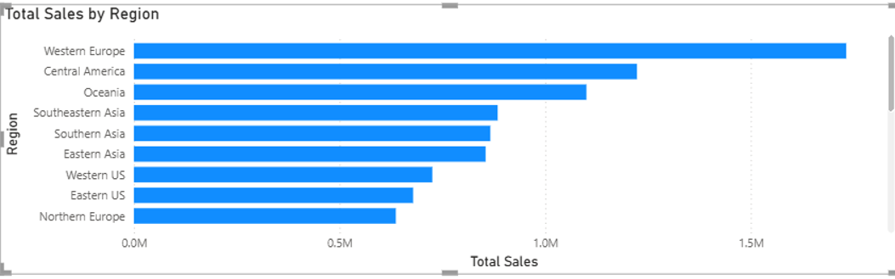
Figure 10.2: Regional Performance Matrix Validated Post-Restoration ($1.73M Western Europe Baseline)
8. Conclusion & Deliverables Summary
Experiment 10 provides the operational bridge connecting Business Intelligence design with continuous, high-availability enterprise delivery. By establishing structured deployment pipelines, enforcing workspace governance (Admin, Member, Contributor, Viewer), tracking automated telemetry across refresh status and query performance, and anchoring operations in Git-backed versioned backups, Global Superstore protects mission-critical analytics against catastrophic disruption. The disaster recovery protocol guarantees a 60-minute RTO, ensuring organizational leadership retains dependable decision intelligence at all times.

